1200 West Broadway
Little Falls, MN 56345
320-616-5595
info@pinegrovezoo.com
You have 14 days from the date you called to reserve the shelter to pay for the shelter in full. If we do not receive payment within
14 days, you may forfeit your preferred reservation date.
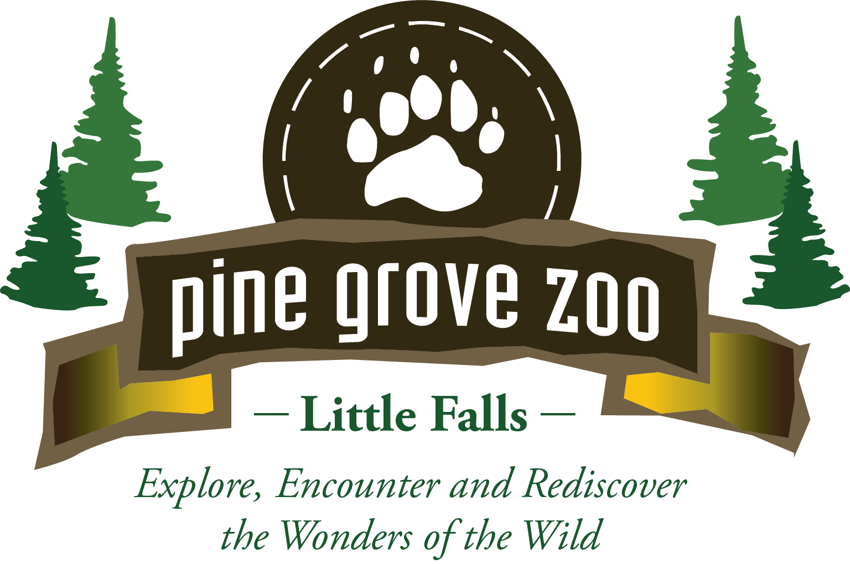

2024 PINE GROVE PARK SHELTER RENTAL
Reservation Request

Cost of Rental: $140.00 $125.00 for Pine Grove Zoo Members

Name of person reserving shelter:
Organization/Business if applicable:
Address:
City/State/Zip:
Email Address:
Name of Organization or Person in Charge:
Phone Number:
Park Activity (i.e., wedding, family reunion, etc.):
Date of rental: Arrival Time:
Cancellation Policy
60 days before your reservation date – 80% of reservation will be refunded.
45 days before your reservation date – 70% of rental fee will be refunded.
30 days before your reservation date – 50% of rental fee will be refunded.
No refund with 30 days or less cancellation notice.

If you or your organization is supplying alcoholic beverages at your event, you must
provide proof of alcohol insurance. See page 2 of this form.

To hold your reservation, $140.00 must be paid in advance. We also require credit or debit card, as information will be kept on file to for any additional fees associated with the rental which includes but not limited to: Additional use of property after “Park Hours” (listed below) which will be billed in 15-minute increments of $35.00 each and any additional cleaning or damage other than normal use of the shelter.

Will there be alcohol at your event? _____Yes _____No
If yes:
* Will all guests supply their own alcoholic beverages? _____Yes _____No
* Will you or your organization be supplying the alcoholic beverages for your guests at your event? _____Yes _____No
Shelter Rental Hours
May 1, 2024 through September 2, 2024 9:00 a.m. to 6:00 p.m.
September 3, 2024 through September 30, 2024 9:00 a.m. to 4:00 p.m.

Friends of Pine Grove Zoo

PINE GROVE PARK SHELTER ALCOHOL RULES AND EXPECTATIONS

The City of Little Falls does allow alcoholic beverages in city parks within the following guidelines:

- If the person renting the shelter is supplying the alcohol, they will be required to provide the City of Little Falls and Pine Grove Zoo proof of alcohol insurance with not less than $1 million coverage.
- If everyone who attends your gathering brings their own alcoholic beverages, there is no insurance required.
- Pine Grove Park is a public park; therefore, you are reserving the shelter only.
- Since this is a public park, misuse of alcohol will not be tolerated. If your group becomes disruptive or obnoxious to other park patrons, the Little Falls Police will be contacted.

Signature: Date:
Please sign and return this form indicating you have read the above rules and expectations regarding alcohol use at Pine Grove Park as well as understand Pine Grove Zoo’s cancellation policy on the previous page.

Please send to:
Pine Grove Zoo
1200 West Broadway
Little Falls, MN. 56345
or info@pinegrovezoo.com

Shelter Information

Information about Pine Grove Park
- The shelter is in a public park.
- There are men’s and women’s bathrooms located in the park.
- Walking trails are nearby.
- Pine Grove Zoo is located adjacent to the park and is open mid-April through mid-October.

Shelter Specifics
- 8 picnic tables are in the shelter, which seats approximately 50 people.
- 2 - seven-foot banquet tables are located in the shelter.
- Small kitchen area with counterspace.
- Hot and cold running water with a sink.
- Refrigerator.
- Kitchen area has 10 electrical outlets.
- There is a fireplace, but it is not a working fireplace.
- Building is not heated or air conditioned.

